Module 3

1. Html tags and elements are different since Html tags are :-html,h1 to h6,title,meta ,body,a etc and html elements are opening and closing bracket <,> 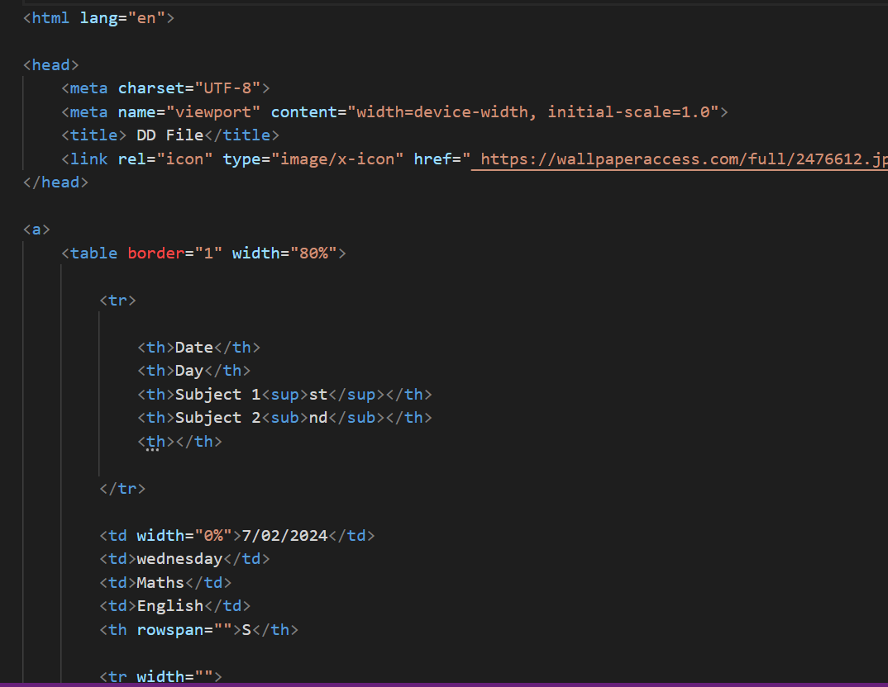
2. Tags:-which defines the property of html I.e. html,h1 to h6,title,meta ,body,a etc these are tags I.e.h1 to h6 defines heading and subheadings of our html,and attribute are href,src inside a,img tag respectively it usually defines the link or url ,img source in html



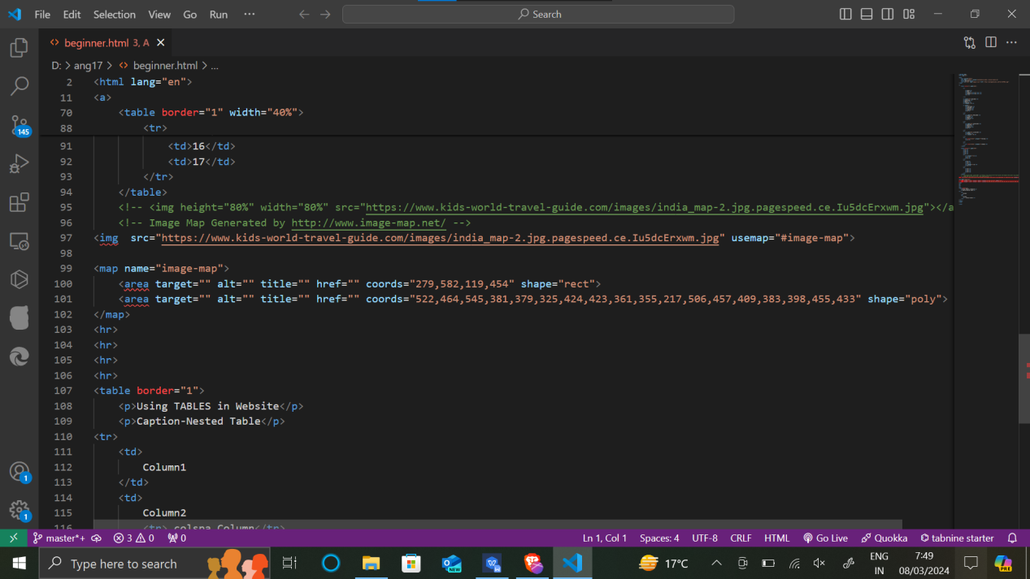

1. What are void elements in HTML? With Example

Self closing tags in html is called void elements I.e img,br,hr,input

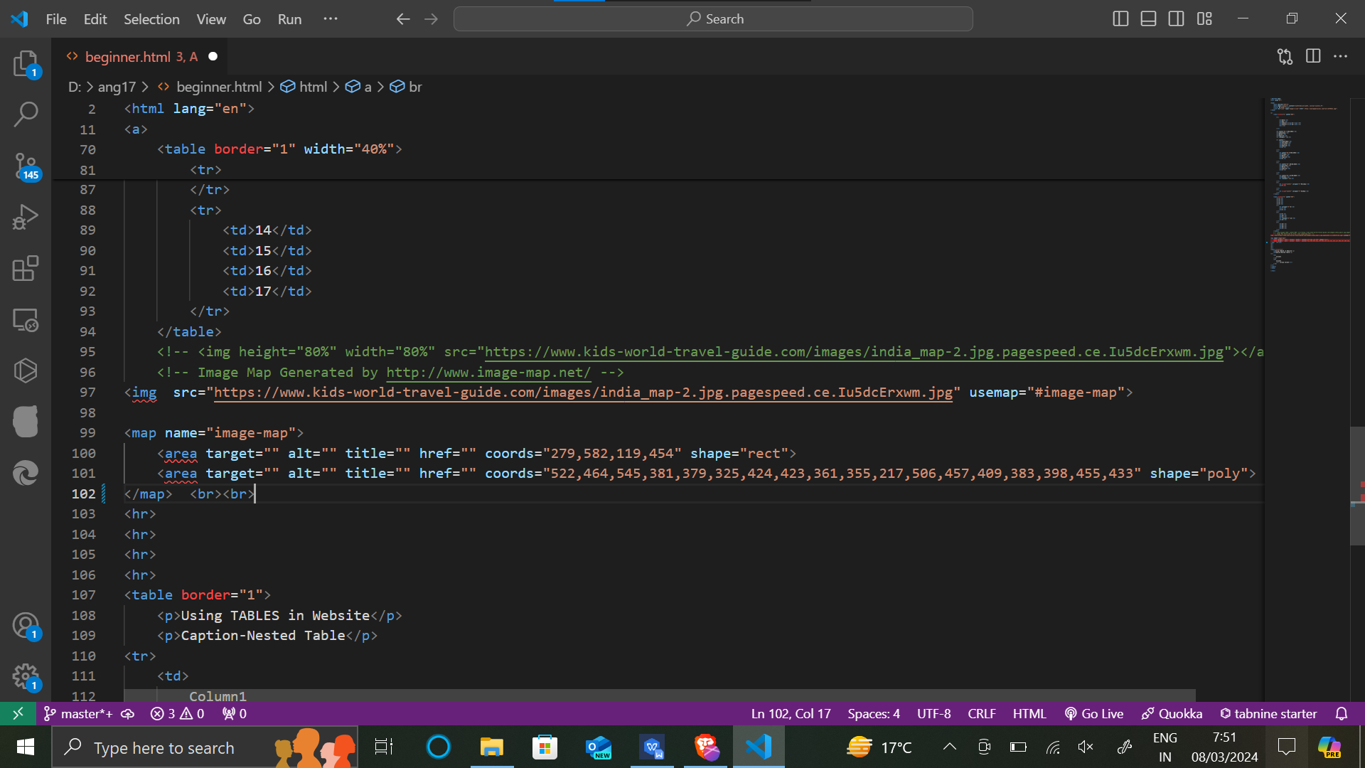

1. What are HTML Entities? With Example.

The opening and closing tags is called html entity <,>



1. What are different types of lists in HTML? With Example.

Different types of lists in html entites are

Ol

<ol><li></li></ol>

Li

<li></li>

Dl

<dl></dl>

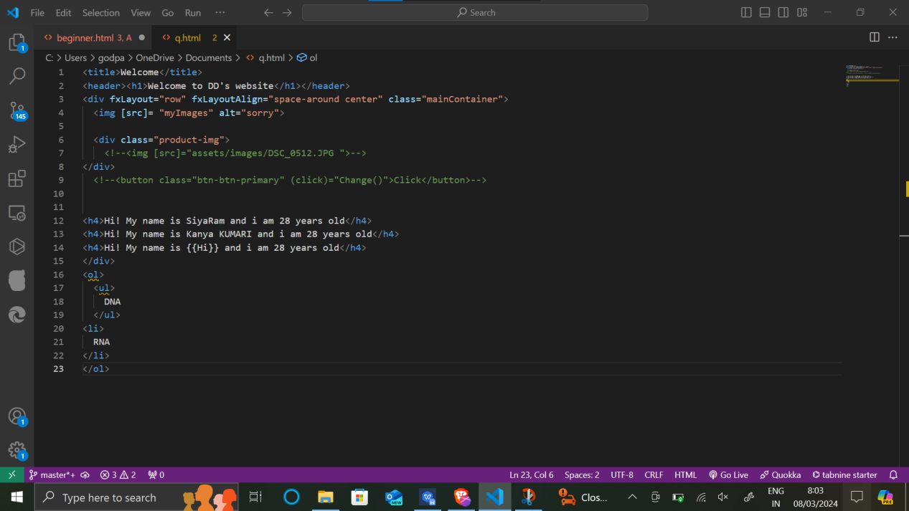

1. What is the ‘class’ attribute in HTML? With Example

Class attribute is used for styling purpose or create uniqueness i.e

<div class=”que”></div>

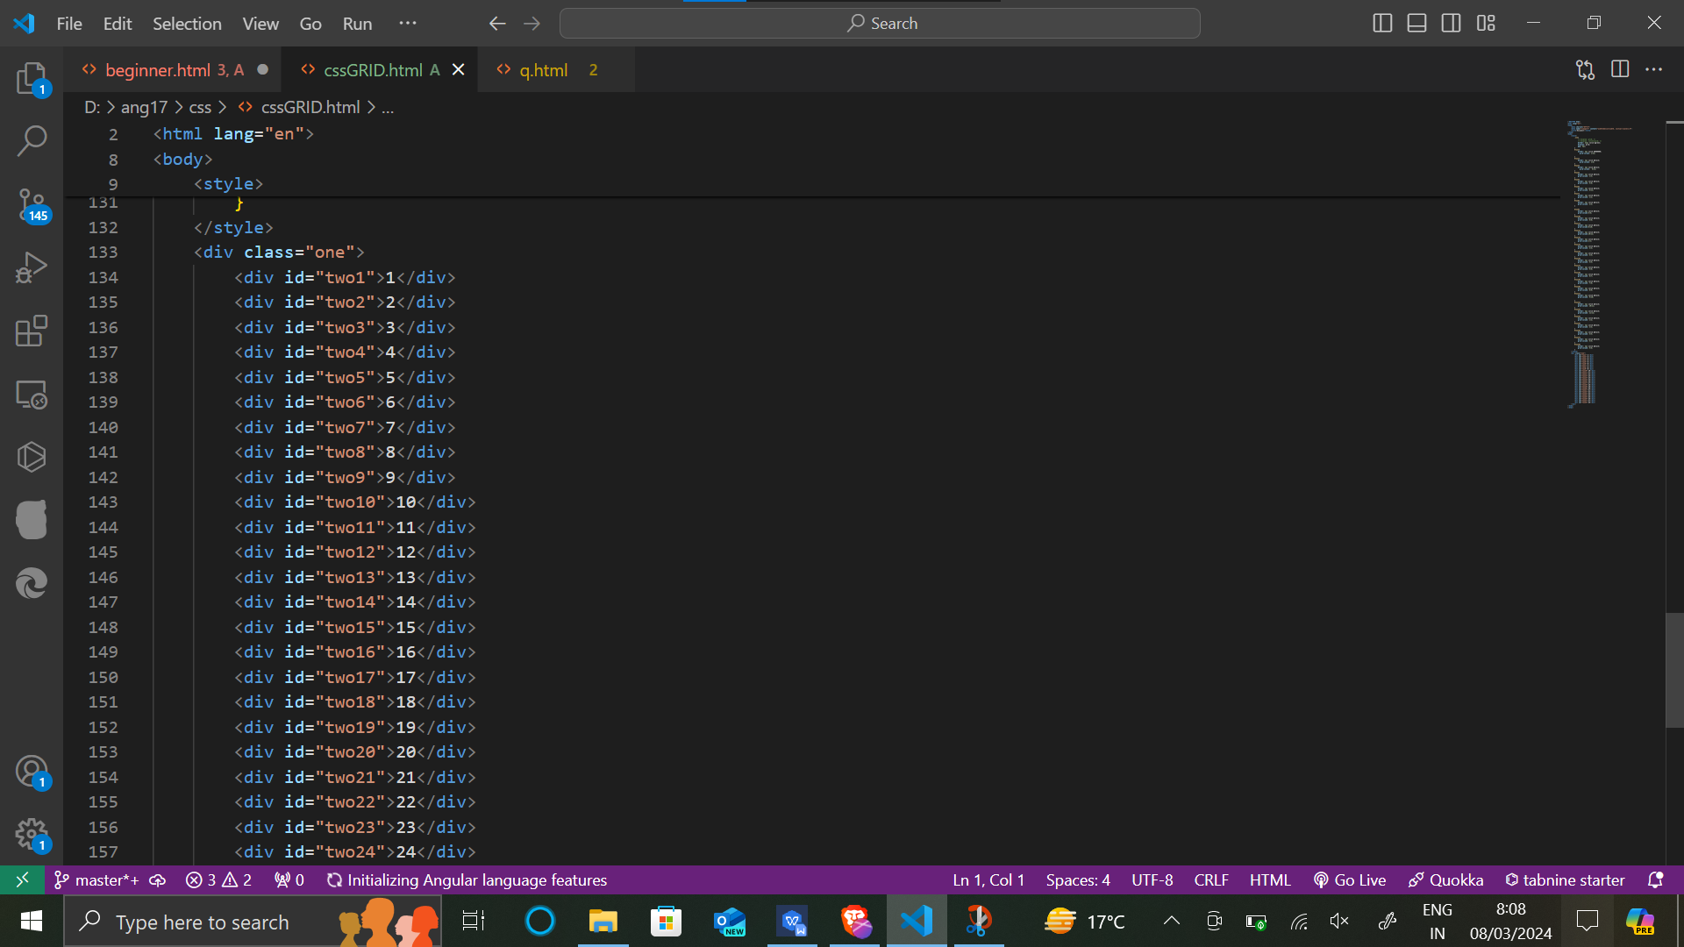

1. What is the difference between the ‘id’ attribute and the ‘class’ attribute of HTML elements? With Example.

Class attribute is used in group or queue of styling purpose since id attribute is used for uniqueness purpose.

<div class=”que”></div>

<div id=”que”></div>



1. What are the various formatting tags in HTML?

Various formatting tags are-

P,b,I,u,del,sub.sup,mark tag

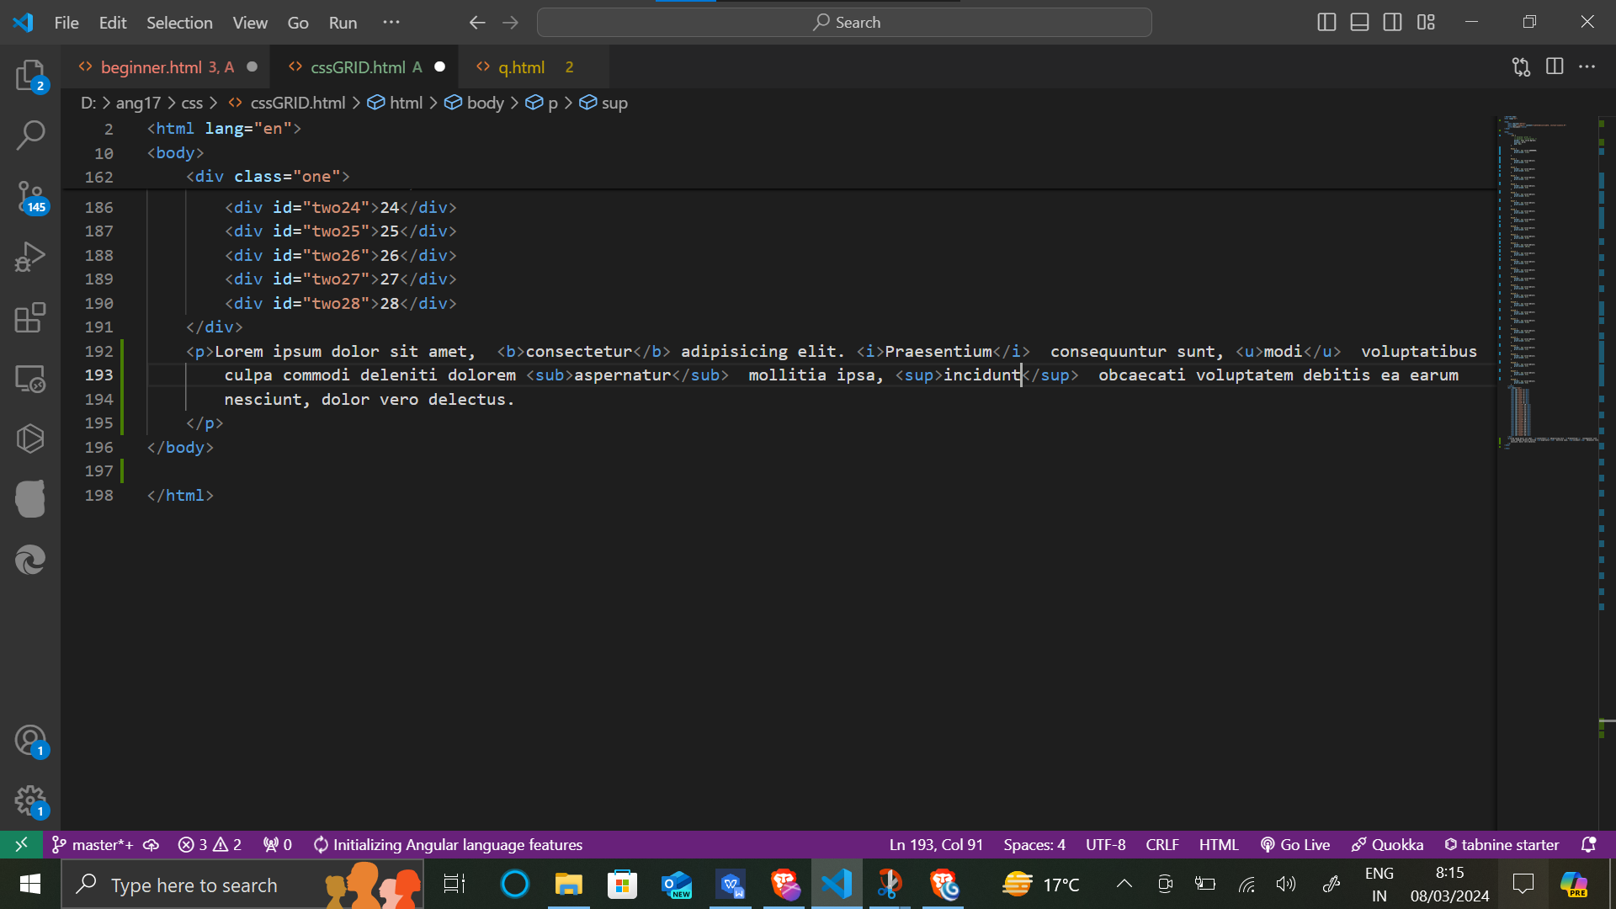

1. How is Cell Padding different from Cell Spacing? With Example.

The difference between cell padding and cell spacing is

1st cell padding gives spacing in the cell and cell spacing gives spacing between the cells

<table border=’1’ cellpadding=’5’></table>

<table border=’1’ cellspacing=’5’></table>

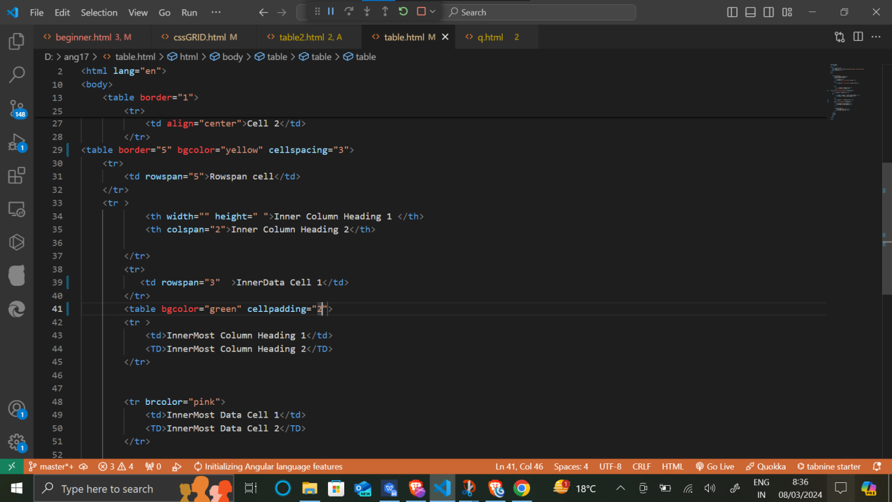

1. How can we club two or more rows or columns into a single row or column in an HTML table? With Example

We can club 2 rows and columns by using colspan and rowspan respectively

<table border="5">

<tr>

<th>Header </th>

<th>Header 2</th>

<th>Header 3</th>

</tr>

<tr>

<td rowspan="2">This cell spans 2 rows</td>

<td> welcome to rowspan </td>

<td> lorem 100</td>

</tr>

<tr>

<td colspan="2">welcome to lorem 100</td>

</tr>

</table>

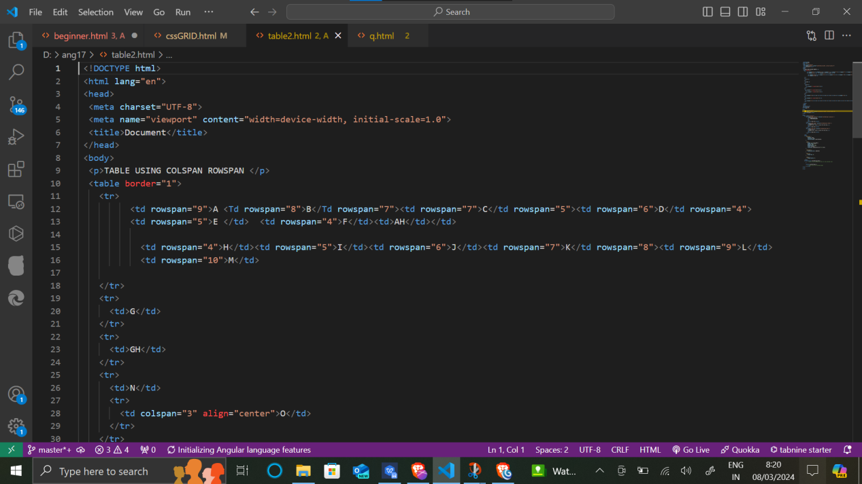

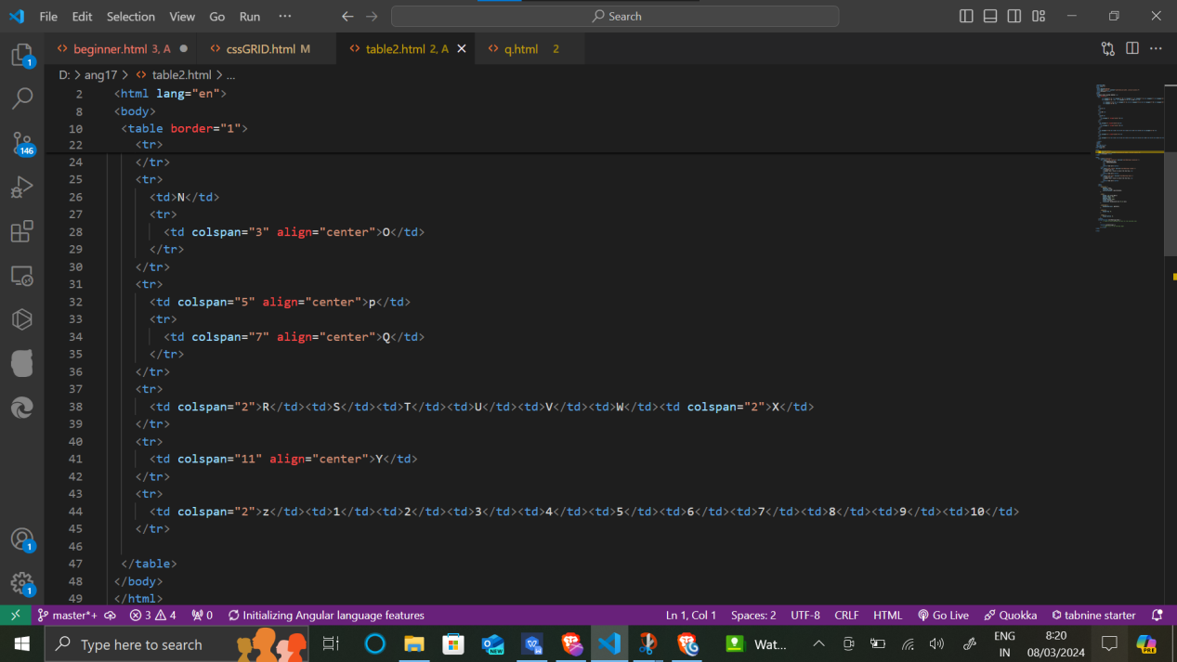

1. What is the difference between a block-level element and an inline element?

The difference between a block-level element and an inline element is

Block level element:-it always starts with a new line

It gives spacing before starting and ending tags.

I.e. p,div tags etc

Inline-level element :-it does not start with new line

it is used for styling purpose.

I.e. <a href=””></a>

Strong, span tags



1. How to create a Hyperlink in HTML? With Example.

The easy way to create hyperlink is use the href tag or hyperlink attribute tag inside anchor tag i.e.

<a href=”google.com”></a>

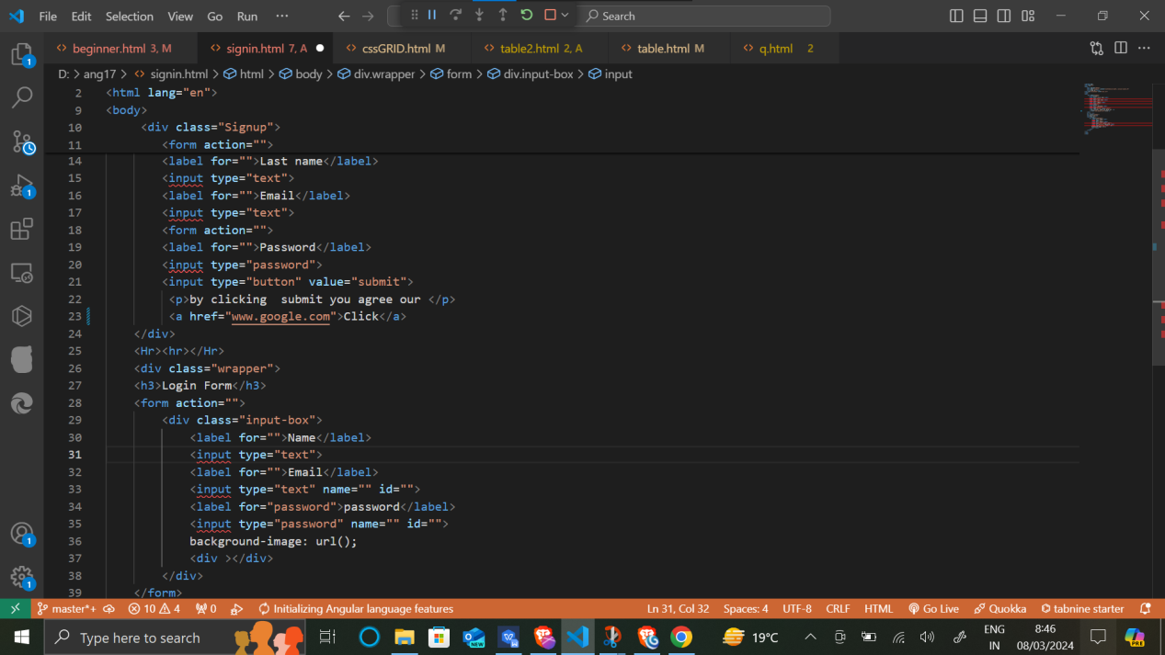

1. What is the use of an iframe tag? With Example.

Iframe tag is use to direct us to various other links whether it is video,map,image,external links,audio etc.

I.e. <iframe src=”zxc.mp4”></iframe>

<iframe src=”zxc.jpg”></iframe>

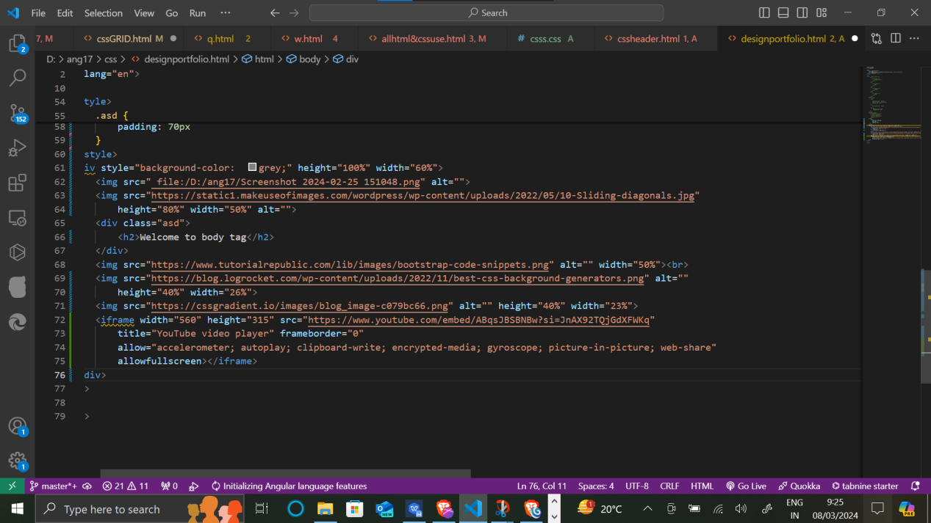

1. What is the use of a span tag? Explain with example?

Span tag is used for css styling purpose for styling specific line, paragraph,text etc I.e

<p>Goog morning to all present over here and <span style =“color:red ”>thankyou for give some time in this task </span> </p>

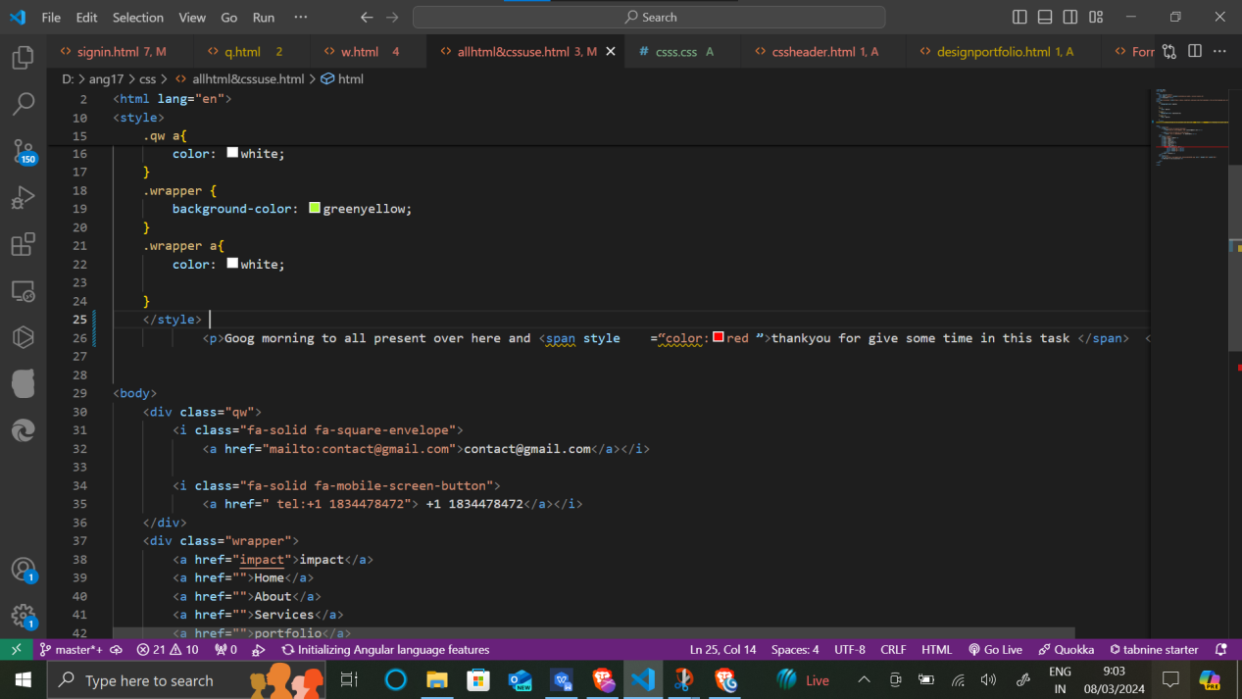

1. How to insert a picture into a background image of a web page? With Example.

To insert image we generally use img tag with src attribute i.e.

<img src=”qwe.jpg”>

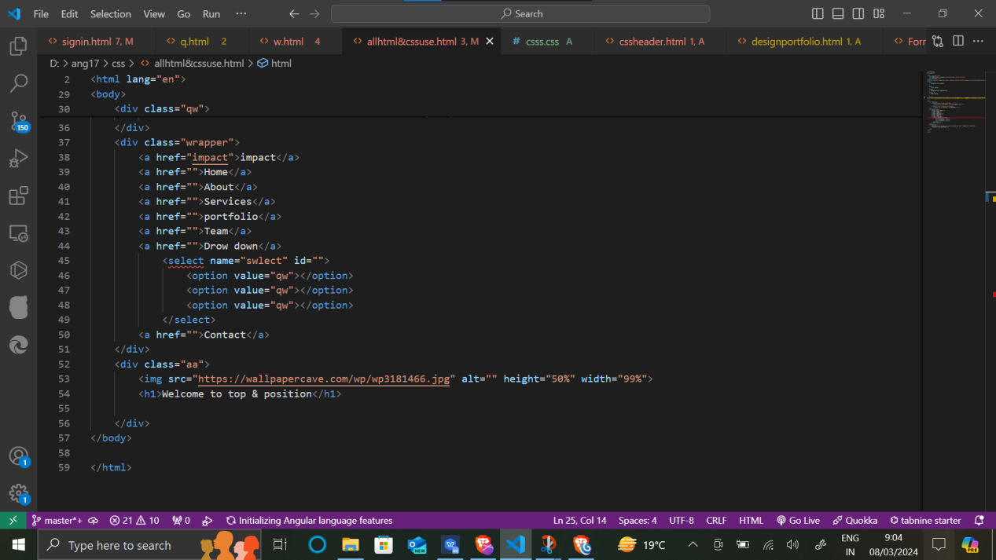

1. How are active links different from normal links?

The difference between active and normal links are

Active link:-it is the link which the user has interacted with it by mouse hovering or by other method.

Normal link:- it is the link which the use user has still not interacted with it.

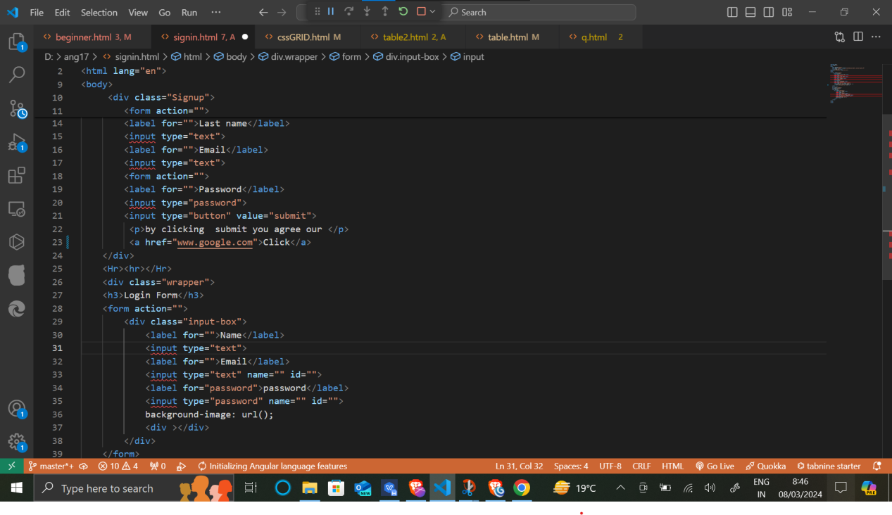

1. What are the different tags to separate sections of text?

the different tags to separate sections of text are

Br tag etc <p> qwertyu ,<br>iop</p>



1. What is SVG?

SVG is a 2d image,xml based vector image.

1. What is difference between HTML and XHTML?

difference between HTML and XHTML is

Doctype declaration is important in xhtml,and html does not require this.

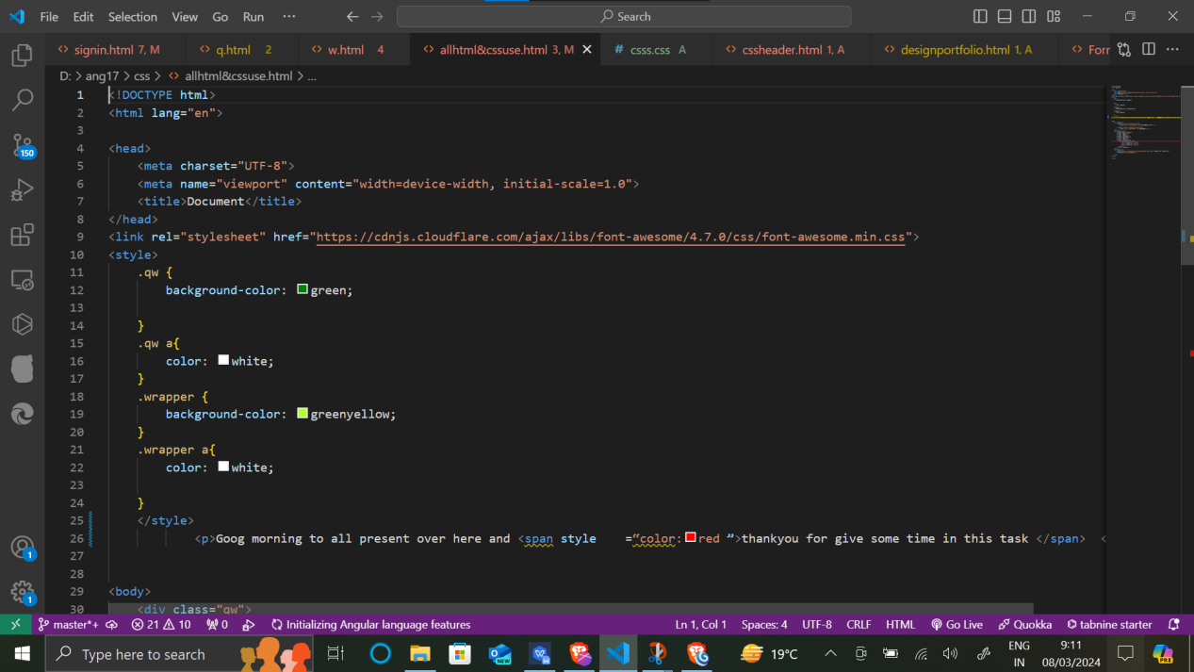

1. What are logical and physical tags in HTML?

Logical tags are also known as structural tags.

it describes logical and structral apparnce about logical tags

I.e del,strong etc

Physical tags defines formatting to the text,or its apparence

I.e I,b,u,sub,sup, etc

